TITLE
Smart Pendant with Wristband: A Safety and Mobility Enhancement Tool for the Elderly and Visually Impaired
AUTHORS
Mohamad Amir Bin Mohamad Yusoff, Adam Hakimi Bin Shah Nur Haizam, Tengku Nurul Ain binti Tengku Azeezee
Department of Mechatronics Engineering, International Islamic University Malaysia
ABSTRACT
This paper presents the development of a dual-ESP32 assistive safety system designed to support visually and hearing-impaired users through intelligent sensing and real-time feedback. The system adopts a distributed architecture in which a master ESP32 handles multi-sensor data acquisition (MPU6050, HuskyLens, DHT11, LDR, and ultrasonic sensor), decision-making, and Telegram-based guardian alerts, while a slave ESP32 manages haptic and audio feedback via a vibration motor and buzzer using ESP-NOW communication. Face recognition is employed as a security mechanism to activate the system, and multi-condition logic is applied to enhance situational awareness. The successful integration of sensor fusion, wireless coordination, and responsive feedback validates the feasibility of a low-cost, reliable assistive technology for vulnerable users.
1. INTRODUCTION
Visually impaired and elderly individuals face ongoing challenges in maintaining independent mobility and personal safety, especially when navigating crowded areas, walking in low-light environments, or responding effectively during emergencies. Conventional walking aids provide limited assistance, as they lack sensing, feedback, and communication capabilities, which increases the risk of collisions, falls, and delayed access to help.
Early smart cane systems primarily focused on obstacle detection using ultrasonic sensors. Dey et al. [1] and Gbenga [2] demonstrated that such approaches can improve navigation, but these systems were limited to basic sensing and did not include emergency alerts or broader environmental monitoring. Subsequent studies introduced communication technologies to enhance user safety. Sharma and Verma [3] and Joseph and Mathew [4] incorporated GPS and emergency alert features, though dependence on GSM networks can increase cost and power consumption.
More recent research has explored intelligent sensing and feedback integration. Ali et al. [5] investigated camera-based assistance systems, while Patel and Mehta [6] introduced water detection to improve environmental awareness. The effectiveness of vibrotactile feedback for navigation support has been confirmed by Silva and Costa [7], and mobile application-based systems further enhanced monitoring and feedback [8]. Khan et al. [9] emphasized health monitoring and emergency alerts, while Zhang and Chen [10] demonstrated the potential of AI-based object recognition, although such systems often involve higher complexity and cost.
Despite these advancements, many existing systems remain costly, complex, or overly dependent on external infrastructure. To address these limitations, this project proposes a low-cost dual-ESP32 assistive system that integrates face authentication, fall detection, obstacle detection, and environmental monitoring using LDR and DHT11 sensors. Multi-modal feedback is provided through vibration and buzzer outputs, while critical events trigger real-time alerts to guardians via Telegram. The use of ESP-NOW communication and sensor fusion offers a practical and user-centered solution compared to existing approaches.

Table 1: Table of comparison
Ref/year | Project name | Advantages | Disadvantages | Comparison to my proposal
– | My Project: Dual-ESP32 Assistive Safety System | Integrates fall detection, face authentication, obstacle detection, temperature monitoring, light detection, and dual alert modes (vibration + buzzer); Telegram-based caregiver alerts; wireless ESP-NOW architecture | Prototype-scale implementation; depends on internet for Telegram alerts | Balanced, practical system focusing on user safety, caregiver communication, and real-world usability
[1] / 2016 | Ultrasonic Sensor Based Smart Blind Stick | Simple and low-cost obstacle detection | No emergency alert; no environmental monitoring | My project adds fall detection, caregiver alerts, and multi-sensor intelligence
[2] / 2017 | Low-Cost Smart Walking Stick for the Blind | Affordable and energy efficient | Limited features; lacks communication and alerts | My project provides intelligent alerts and multi-modal feedback
[3] / 2021 | IoT Based Smart Cane with GPS and Emergency Alert | Supports caregiver communication and tracking | Relies heavily on internet; no obstacle–light interaction | My project adds local safety responses such as vibration and buzzer alerts
[4] / 2021 | GSM and GPS Enabled Smart Stick | Emergency alert supported | Higher power usage; limited sensing features | My project integrates more sensors with efficient ESP-NOW communication
[5] / 2020 | Smart Stick Using IR Camera and Cloud API | Object recognition and AI capability | Complex setup; requires mobile device | My project uses local face recognition (HuskyLens) without app dependency
[6] / 2020 | Smart Stick with Obstacle and Water Detection | Improves environmental awareness | No caregiver alert; no authentication system | My project adds fall alerts and identity-based activation
[7] / 2018 | Vibrotactile Feedback Navigation System | Effective haptic guidance | Focused only on feedback, not communication | My project combines feedback with IoT-based alerts
[8] / 2020 | Mobile App-Based Smart Cane | Rich features via mobile integration | Requires smartphone at all times | My project works independently without needing phone interaction
[9] / 2020 | Smart Stick with Health Monitoring | Includes safety and physiological monitoring | Limited environmental awareness | My project combines both environmental sensing and user monitoring
[10] / 2022 | AI-Based Smart Stick with Object Recognition | Advanced real-time object detection | Expensive hardware; high power usage | My project is more affordable and suitable for real-world deployment

2. METHODOLOGY

2.1 Project Development

Overall, the block diagram provides an overview of the complete system by illustrating the relationship between the input components, output devices, and microcontrollers. This project consists of four functional systems: System 1 (Face Recognition Activation System), System 2 (Fall Detection, Temperature and Guardian Alert System), System 3 (Environmental and Obstacle Detection System), and System 4 (Haptic and Audio Feedback System).

The block diagram for System 1 is shown in Fig. 1, illustrating the use of the HuskyLens for system activation with vibration feedback. Fig. 2 presents the combined block diagram of Systems 2, 3, and 4, demonstrating the integration of multiple sensors and output devices. This combined diagram highlights the coordination between the subsystems to ensure overall system efficiency. Fig. 3 shows the system flowchart, which represents the working principles and operational logic of all four systems.

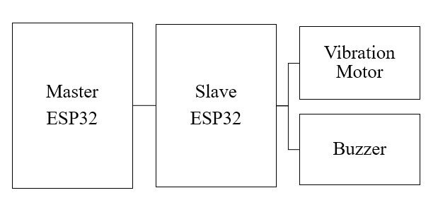

Fig. 1 Block diagram of System 1 for Smart Pendant
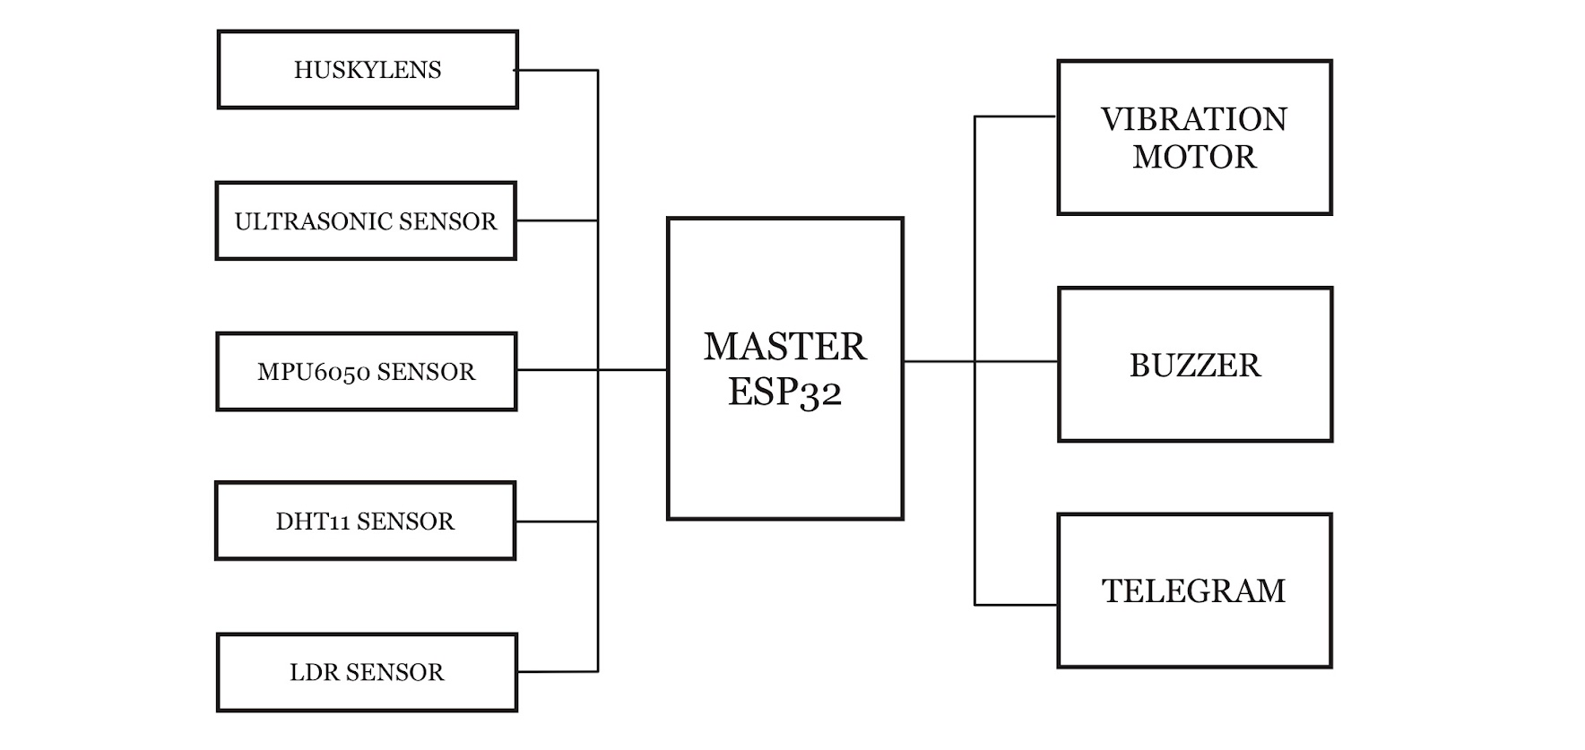Fig. 2 Block diagram of System 2 for Smart Wristband
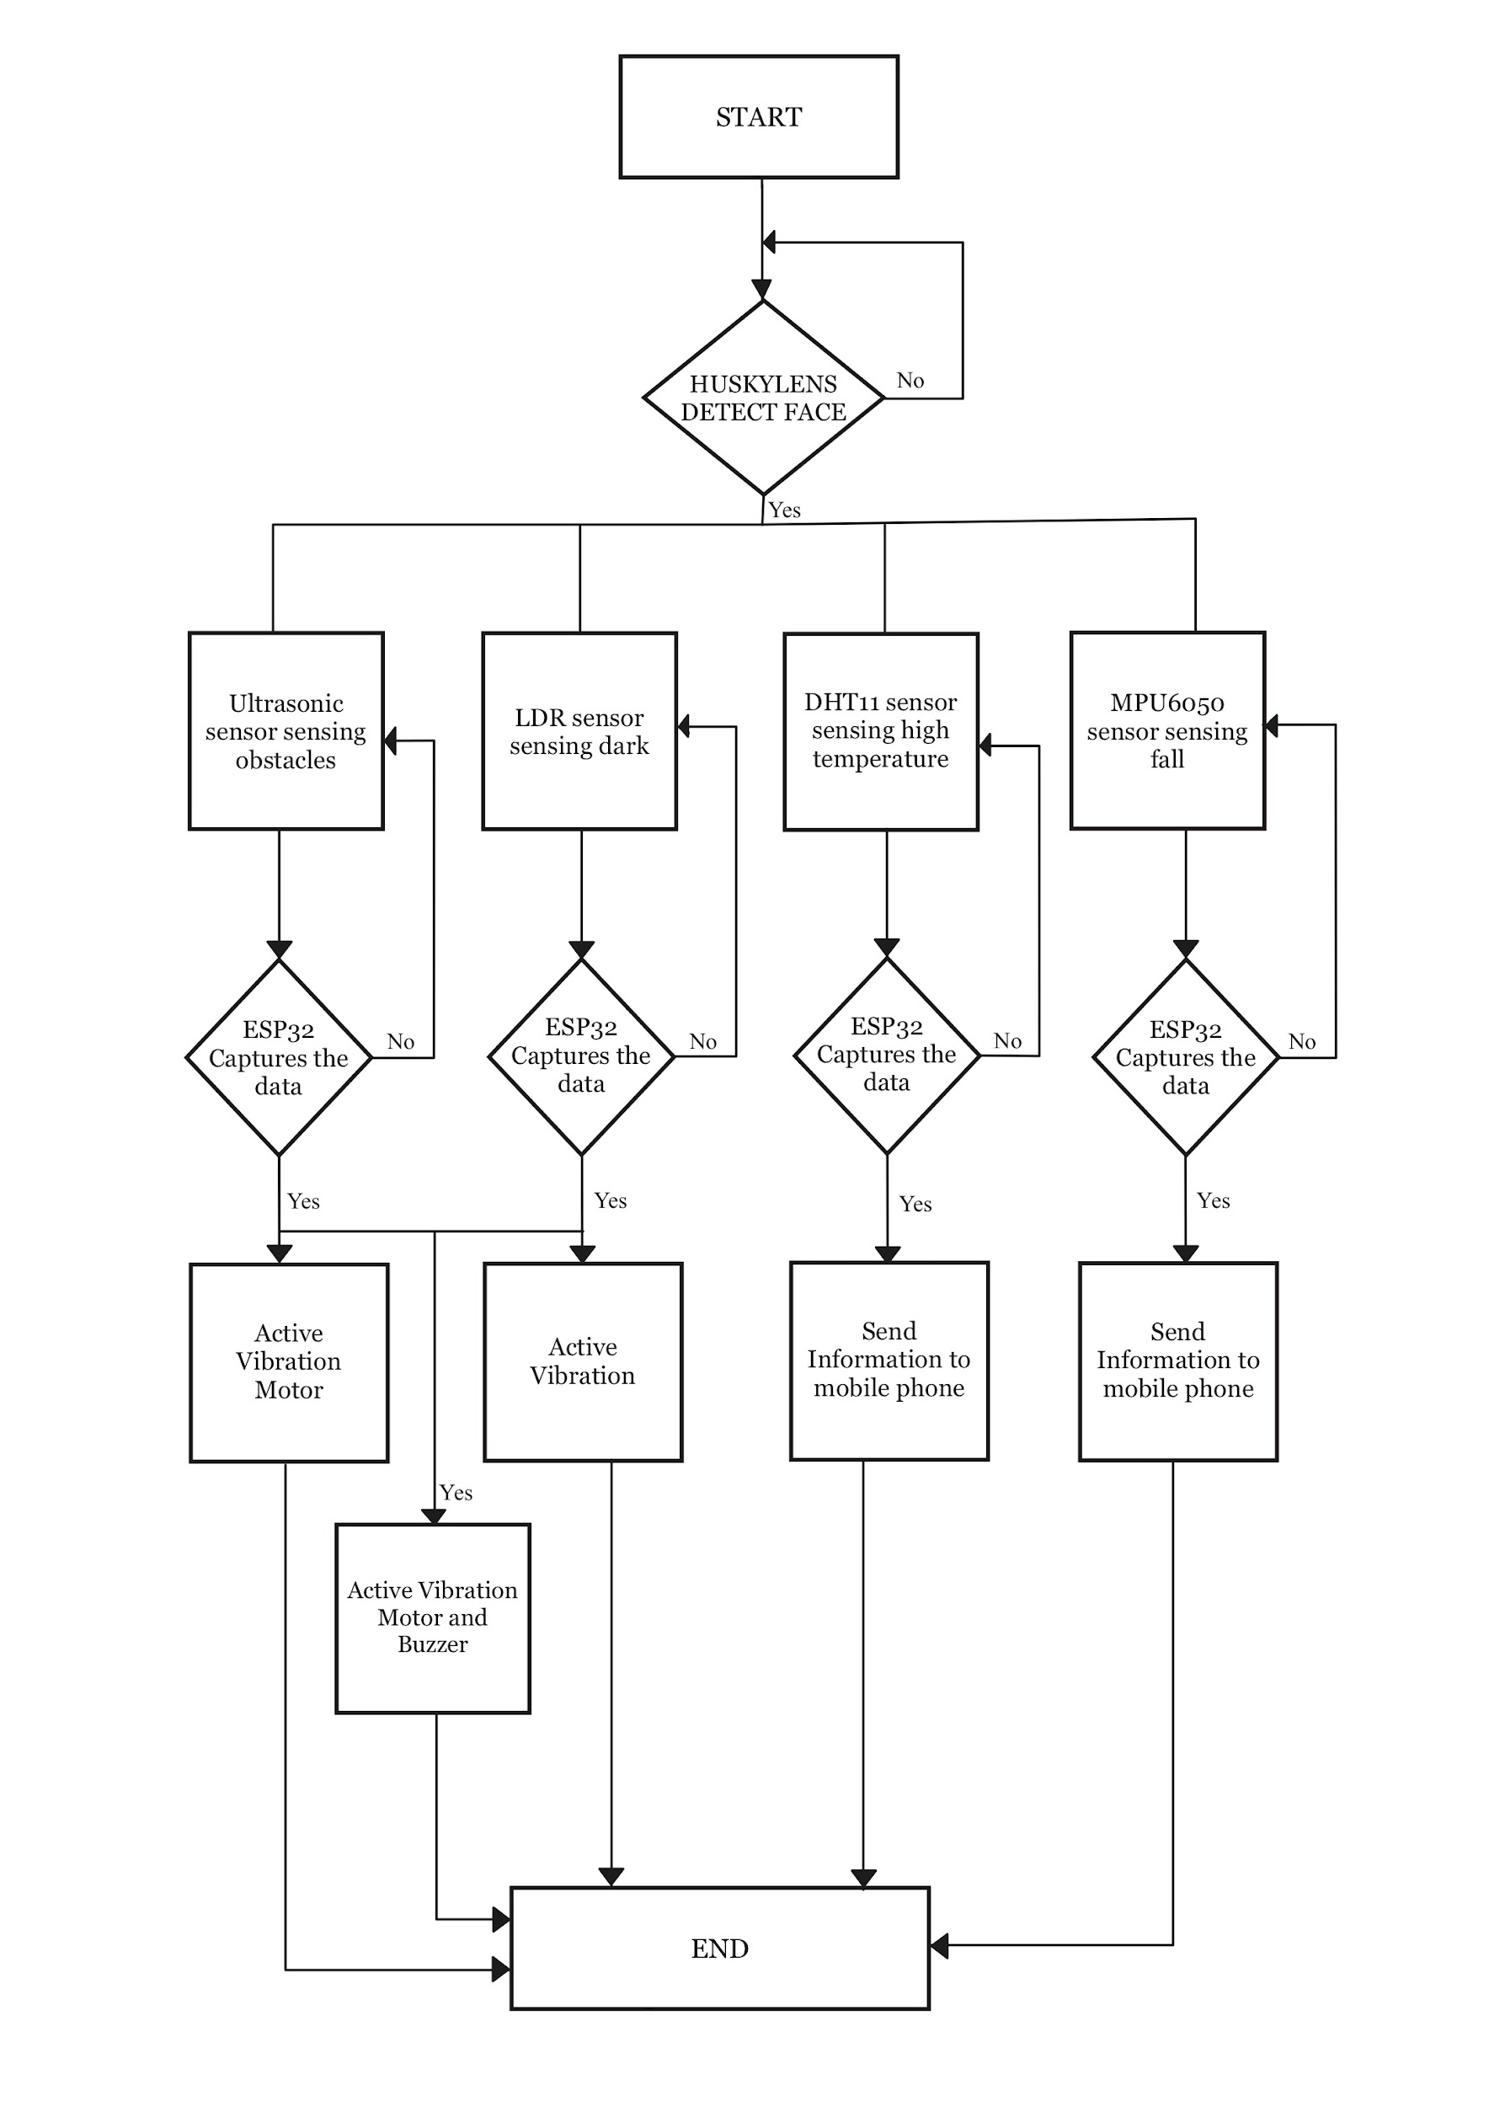
Fig. 3 The flow chart that explains all the work principles for the Smart Pendant And Wristband project

2.2 Schematic Diagram and Prototype Setup

Fig. 4 shows the circuit diagram of System 4 (Haptic and Audio Feedback System), where the vibration motor and buzzer are interfaced with the slave ESP32 to provide tactile and audio alerts based on the received commands. This schematic highlights the electrical configuration of the output components used for user and environmental warning.

Fig. 5 presents the circuit diagrams of the remaining systems (Systems 1, 2, and 3), which include the integration of the HuskyLens for face recognition activation, the MPU6050 for fall detection, and the DHT11, LDR, and ultrasonic sensor for environmental and obstacle monitoring. These diagrams illustrate the hardware connections of the sensing and control components with the master ESP32.

Fig. 4 Electrical Design of the Vibrator Module and Buzzer System (System 4)
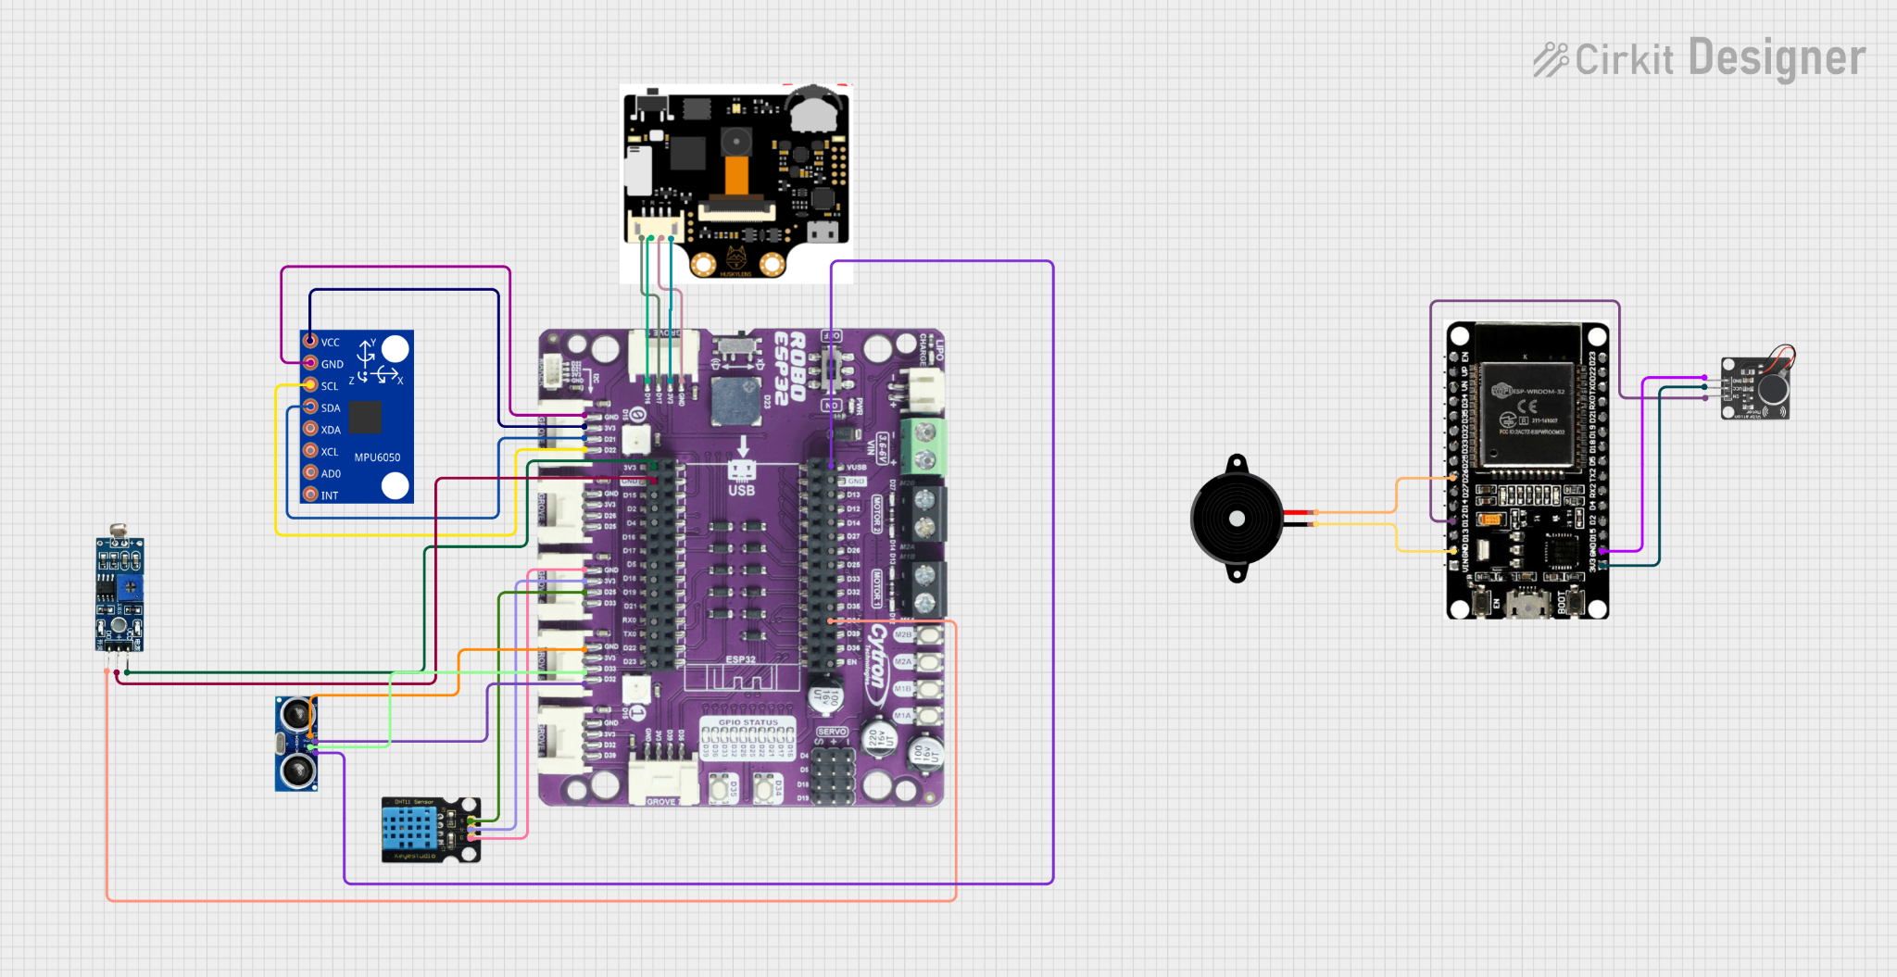

Fig. 5 Electrical Design of System 1, System 2 and System 3

Fig. 6 The Smart Pendant And Wristband (Gemini)

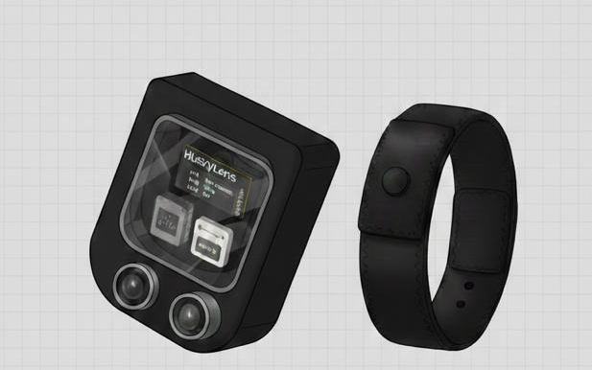

3. RESULT AND DISCUSSION
3.1 System 1 (User Authentication and System Activation) Analysis
System 1 is responsible for user authentication and system activation through face recognition using the HuskyLens vision sensor. Three authorized user faces were pre-registered in the HuskyLens to restrict system access to legitimate users. When a registered face is successfully recognized, the master ESP32 activates the system and sends a command to the slave ESP32, which triggers the vibration motor for three seconds to provide haptic confirmation that the system is operational.
The performance of the face recognition module was evaluated under varying lighting conditions and face orientations. Rather than relying on arbitrary values, the evaluation was conducted by repeating recognition trials under each condition and observing both the recognition success rate and the response time behavior. Quantitative results represent the proportion of successful recognitions, while qualitative descriptors (fast, moderate, slow) are used to describe the observed response time trends. Table 1 presents the combined quantitative and qualitative evaluation of the system.

Table 2 : Face recognition performance of HuskyLens under different operating conditions
Lighting Condition | Face Orientation | Recognition Outcome | Recognition Success | Response Time (Qualitative) | System Feedback
Bright lighting | Frontal | Consistently detected | High | Fast | Immediate vibration
Normal lighting | 15°–30° angle | Mostly detected | High | Fast | Immediate vibration
Low lighting | Frontal | Occasionally missed | Moderate | Moderate | Slight delay observed
Low lighting | 30°–45° angle | Frequently missed | Low | Slow | Noticeable delay

Table 3 : Comparative Summary Table

Condition Category | Overall Performance
Bright / frontal | Best overall performance
Normal / angled | Reliable performance
Low light / frontal | Acceptable but reduced performance
Low light / angled | Least reliable condition

3.2 System 2 (Fall Detection, Temperature Alerts and Guardian Alert System) Analysis
System 2 is designed to detect sudden falls and abnormal environmental conditions that may indicate user distress, and automatically notify a guardian through Telegram messaging. The MPU6050 module is used to monitor motion patterns and body orientation in real time, while the DHT11 sensor is used to monitor ambient temperature that may affect user safety.
A fall is detected when the acceleration magnitude exceeds a predefined threshold 2.0, followed by a rapid change in body orientation within a short time interval 0.1s. Once a fall is confirmed, the master ESP32 immediately activates the emergency routine and sends an alert message to the guardian via Telegram using Wi-Fi connectivity. The message notifies that a fall has occurred and that immediate assistance may be required.
In addition to fall detection, the DHT11 sensor monitors surrounding temperature to identify potentially unsafe conditions, such as excessive heat that could contribute to fatigue, dizziness, or dehydration. When the temperature exceeds a predefined safety threshold 30°C, the system can also trigger warning feedback to the user and optionally send a notification to the guardian, indicating possible environmental risk even if no fall is detected.
Fig. 7a Shows the Fall Detection System is activated and sends notification to the guardian.
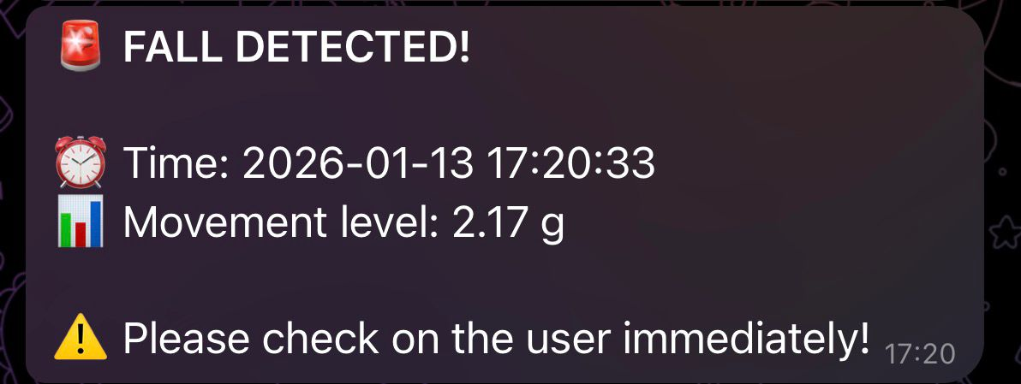
Fig. 7b Shows the High Temperature System is activated and sends notification to the guardian.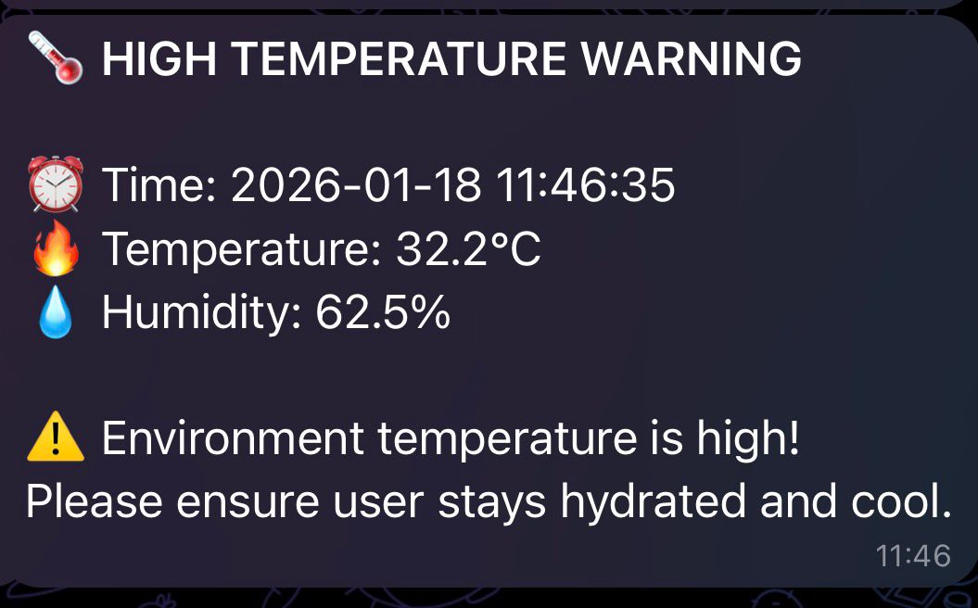
3.3 System 3 (Environmental Monitoring and User Awareness System) Analysis
System 3 is designed to monitor environmental conditions and enhance user awareness by detecting low-light environments and nearby obstacles. This system integrates an LDR for darkness detection and an ultrasonic sensor for obstacle detection. Based on the sensor inputs, the system provides haptic and audio feedback to alert the user of potential hazards in their surroundings.
When the LDR detects a dark environment, the vibration motor is activated twice to notify the user of reduced visibility. If the ultrasonic sensor detects an obstacle at a distance of less than 50 cm, continuous vibration is triggered to warn the user of an immediate physical obstruction. In situations where both low-light conditions and nearby obstacles are detected simultaneously, the system activates both continuous vibration and the buzzer to provide a stronger multimodal alert, ensuring the user is clearly informed of the increased risk and to alert everyone surrounding.
To evaluate the effectiveness and reliability of the ultrasonic sensor, testing was conducted using two different types of materials: a curtain (soft surface) and a wall (hard surface). These tests were performed to observe the sensor’s response to varying obstacle textures and reflectivity. The results confirmed that the system is capable of detecting both soft and hard obstacles, demonstrating its effectiveness in real-world environments where different materials may be present.
Table 4 : Vibrator and Buzzer responses for different environmental scenarios.

SCENARIOS | CONDITIONS | VIBRATION RESPONSE | BUZZER
LDR | Dark | Vibrate 2 times | OFF
LDR | Bright | OFF | OFF
Ultrasonic | Obstacles <50cm | Vibrate Continuously | OFF
Ultrasonic | Obstacles >50cm | OFF | OFF
Ultrasonic + LDR | DARK + Obstacle < 30 cm | Vibrate Continuously | ON
Table 5 : Obstacle Detection Test on Wall and Curtain

Distance (cm) | Material | Sensor Status | Vibration Status
15 | Wall | Active | Active
15 | Curtain | Active | Active
30 | Wall | Active | Active
30 | Curtain | Active | Active
50 | Wall | Active | Active
50 | Curtain | Active | Active
60 | Wall | Active | Not Active
60 | Curtain | Active | Not Active

Figure 8 Obstacle Detection Testing Based on Surface Material and Distance

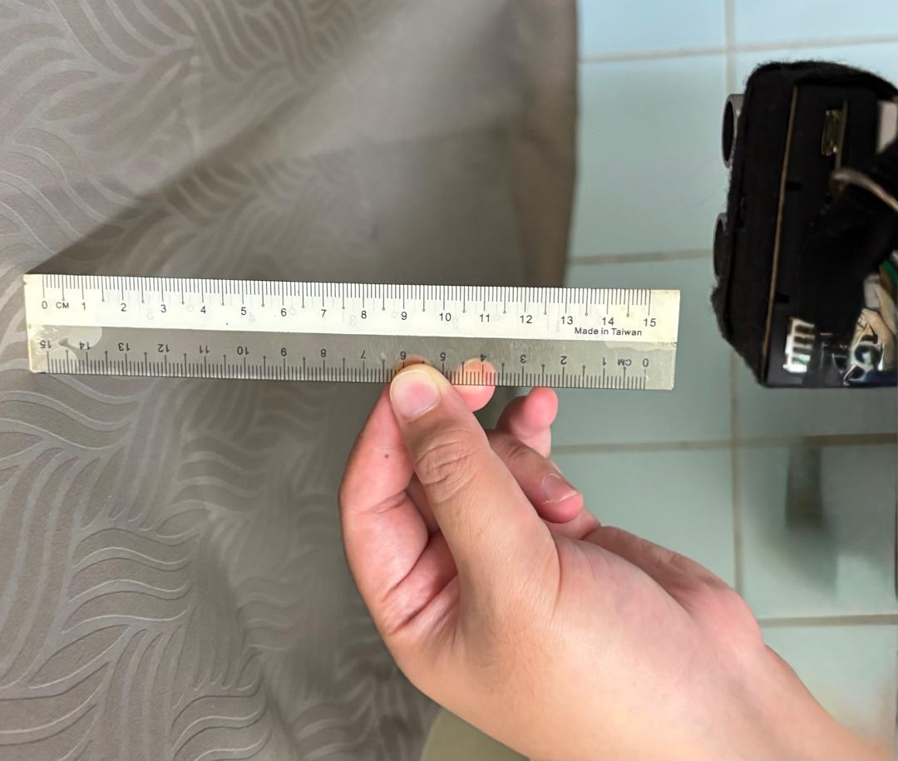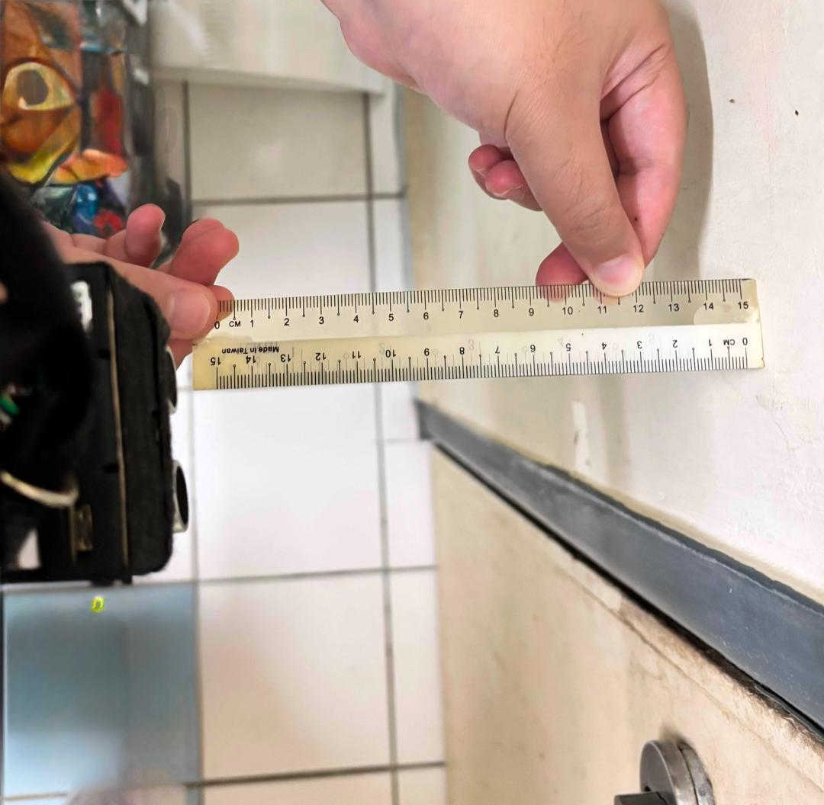
Figure 8a : Curtain Figure 8b : Wall

3.4 System 4 (Haptic and Audio Feedback System) Analysis
System 4 is responsible for delivering tactile and audio feedback to the user and surrounding people based on sensor inputs from the master ESP32. The vibration motor and buzzer are activated according to specific conditions: vibration is triggered three times in low-light situations detected by the LDR, continuous vibration occurs when obstacles are within 50 cm of the user, and the buzzer sounds when low-light conditions and nearby obstacles occur simultaneously.
Table 6 presents the vibration intensity and duration responses for different scenarios, while Table 7 shows the buzzer activation in combined conditions. Maximum values indicate the strongest haptic or audio feedback, minimum values represent the least noticeable response, and average values provide an overall assessment of feedback performance. These measurements help ensure that the feedback system reliably communicates environmental hazards to the user and nearby individuals.
Table 6 : Vibration Output for different Scenarios

SCENARIOS | CONDITIONS | VIBRATION DURATION | VIBRATION INTENSITY
HuskyLens | Face Detected (System Unlock) | 3s Continuous Vibration | Minimum
HuskyLens | Face Undetected (System Lock) | No Vibration | N/A
LDR | Dark | 3 consecutive Vibration | Maximum
LDR | Bright | No Vibration | N/A
Ultrasonic | Obstacle< 50cm | Continuous Vibration | Maximum
Ultrasonic | Obstacle > 50cm | No Vibration | N/A

Table 7 : Buzzer Activation in Combined Conditions
LDR CONDITION | ULTRASONIC CONDITION | BUZZER ACTIVATION | BUZZER INTENSITY
DARK | Obstacle > 50cm | Buzzer Deactivated | N/A
DARK | Obstacle < 50cm | Buzzer Activated | Maximum
BRIGHT | Obstacle > 50cm | Buzzer Deactivated | N/A
BRIGHT | Obstacle < 50cm | Buzzer Deactivated | N/A

4. CONCLUSION
In conclusion, the proposed assistive system has successfully achieved its objectives of enhancing safety and awareness for visually and hearing-impaired users. The project effectively integrates multiple functions, including face recognition-based system activation, fall detection, environmental monitoring, and real-time haptic and audio feedback using a dual-ESP32 architecture with wireless ESP-NOW communication.
The prototype demonstrates the practical application of IoT and embedded systems in assistive technology, providing valuable insights into sensor integration, circuit implementation, and user-centered design. For future improvements, the system could incorporate advanced sensors such as LiDAR, solar-powered energy, real-time GPS tracking with cloud-based alerts, voice responses, and lighter ergonomic designs. Additionally, integrating AI-based adaptive learning could enhance user personalization, making the system more intelligent, responsive, and effective as a mobility and safety aid.

Acknowledgement
The authors would like to thank the Mechatronics System Integrations laboratory staff for providing the necessary components and technical support for this project.
Conflict of Interest
Authors declare that there is no conflict of interest regarding the publication of the paper.
Author Contribution
The author attests to having sole responsibility for the following: planning and designing the study, data, collection, analysis and interpretation of the outcomes, and paper writing

REFERENCES
[1] S. Dey, A. Roy, and S. Das, “Ultrasonic sensor based smart blind stick,” International Journal of Computer Applications, vol. 145, no. 10, pp. 15–18, 2016. https://www.ijcaonline.org/archives/volume145/number10/25536-2016903638
[2] O. Gbenga, “Development of a low-cost smart walking stick for the blind,” International Journal of Scientific and Engineering Research, vol. 8, no. 5, pp. 112–117, 2017. https://www.ijser.org/researchpaper/Development-of-Low-Cost-Smart-Walking-Stick-for-the-Blind.pdf
[3] P. Sharma and T. Verma, “IoT based smart cane with GPS tracking and emergency alert,” International Journal of Advanced Research in Electronics and Communication Engineering, vol. 10, no. 2, pp. 91–96, 2021. https://ijarece.org/wp-content/uploads/2021/02/IJARECE-VOL-10-ISSUE-2-91-96.pdf
[4] A. Joseph and P. Mathew, “GSM and GPS enabled smart stick for safety monitoring,” International Journal of Engineering Science and Computing, vol. 11, no. 3, pp. 27834–27838, 2021. https://www.ijesc.org/upload/2021/march/137_IJESC_137.pdf
[5] M. Ali, S. Noor, and H. Rahman, “Smart electronic stick using IR camera and Google API for visually impaired,” Procedia Computer Science, vol. 167, pp. 130–137, 2020. https://www.sciencedirect.com/science/article/pii/S1877050920313890
[6] K. Patel and R. Mehta, “Smart blind stick with obstacle and water detection system,” International Journal of Innovative Technology and Exploring Engineering, vol. 9, no. 6, pp. 2278–2283, 2020. https://www.ijitee.org/wp-content/uploads/papers/v9i6/F6652049620.pdf
[7] R. Silva and J. Costa, “Vibrotactile feedback system for assistive navigation,” Sensors, vol. 18, no. 11, pp. 1–14, 2018. https://www.mdpi.com/1424-8220/18/11/3807
[8] T. Nguyen and D. Tran, “Mobile application-based smart cane with intelligent feedback,” IEEE Access, vol. 8, pp. 112345–112353, 2020. https://ieeexplore.ieee.org/document/9126631
[9] A. Khan, M. Iqbal, and S. Raza, “Smart walking stick with health monitoring and emergency alert,” International Journal of Engineering Research and Technology, vol. 9, no. 5, pp. 620–625, 2020. https://www.ijert.org/research/smart-walking-stick-with-health-monitoring-and-emergency-alert-IJERTV9IS050834.pdf
[10] L. Zhang and Y. Chen, “AI-based smart stick for visually impaired using real-time object recognition,” IEEE Sensors Journal, vol. 22, no. 4, pp. 3562–3570, 2022. https://ieeexplore.ieee.org/document/9754235

